START
Display “This program calculates the Quadratic formula using the quadratic equation for three given variables”
Read a,b, and c
while a==0
Display “a” must be higher or lower than zero please re-enter the variables
Read a, b, and c
If (b*b-4*a*c) ==0
X1= (-b + sqrt(b*b-4*a*c))/(2*a)
X2= (-b - sqrt(b*b-4*a*c))/(2*a)

Display “The two real solutions are”
Display x1 x2
Else If (b*b-4*a*c) >0
X= (-b + sqrt(b*b-4*a*c))/(2*a)
Display “The real solution is”
Display x
Else
Display “The two complex solutions are”
X1= (-b/2*a) + (sqrt(-(b*b-4*a*c)
X2= (-b/2*a) – (sqrt(-(b*b-4*a*c)
Display x1 x2
END
False Loop
False
False
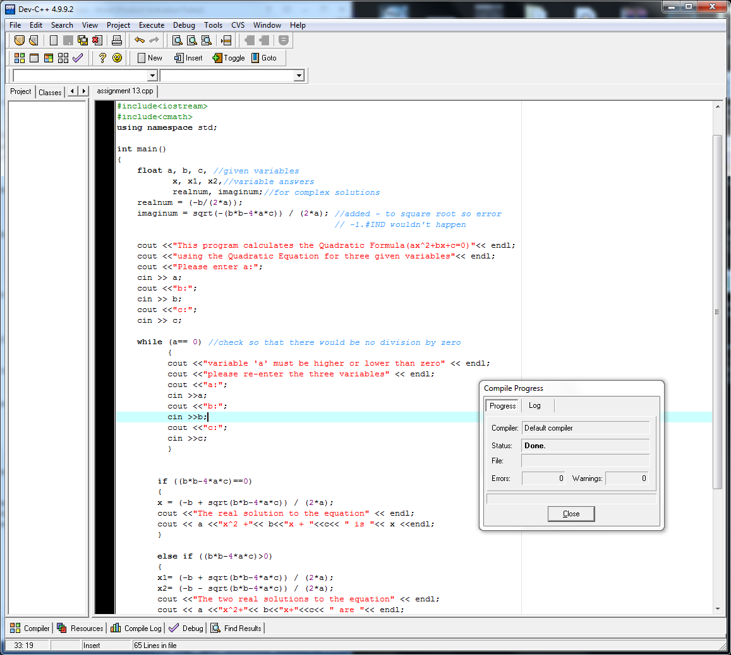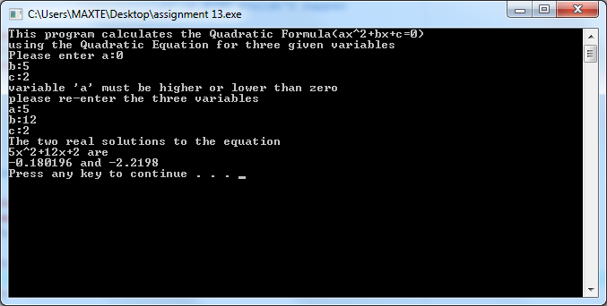
- Clearly state the problem.

Must give real or complex solutions to given variables of the Quadratic Formula (ax^2+bx+c).

- What values need to be supplied by the user of the program?

Values for a, b, and c

- Do you need to place any restrictions on user input (input validation)? If so, specify the conditions.

“a” must not equal zero for that would be division by zero.

- Analyze different kinds of methods (at least 3) that can be used solve a quadratic equation. (If your math is rusty, do some internet research or dig up your old algebra book.) Is any one of the methods more suitable than the others, from the software development point of view? If so, which one, and why?
Using the quadratic equation ((-b +-(b*b-4*a*c))/(2*a)) is more suitable for software development because it is a set equation that works and gives one or two real and complex solutions to the quadratic formula, thus making it unnecessary to code factoring.

- Select the most suitable method for solving this problem. Are there any 'special cases' that you need to consider? If so, enumerate them.

Ask the user for a, b, and c. if a is 0 use the while loop until it isn’t. Calculate the Quadratic equation with if functions. If answer is 0 then it’s one real solution. If it’s more than 0 then it’s two. If answer is anything else then it is two complex solutions.
“Special cases”:
If the answer is two complex solutions then the imaginary number “i “must come into play. For the answer to be two complex solutions, there must be a negative inside the root which would cause the error “-1.#IND”. To solve this there must be a negative before (b*b-4*a*c) in the root to make it positive then manually add the + , -, and “i “ in the cout<<.

- Analyze different ways of presenting output to the user. For example, compare the difficulty of presenting the solution in these two forms:
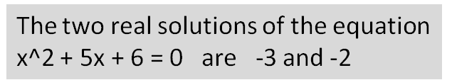
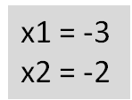

Select an output representation (possibly, but not necessarily one of the above) that balances programming complexity and user friendliness.
Used the second because I felt it seemed more user friendly

- Use instructor-designated design-stage tool(s) to specify the complete algorithm.

- Are there any calculations performed several times? If so, design your program so the repetition is avoided.

- Implement your program. Test your program thoroughly.

- Turn in your
- source code (.cpp) file,
- completed design document(s),
- screenshots of program runs,
- as well as this document with all questions answered.

